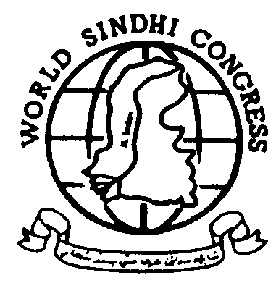WORLD SINDHI CONGRESS
UK: 769 Manchester Road, Bankfoot Bradford, BD5 8LN, UK
Phone: +44-1274-742609 ~ Fax. +44-1274-730627
USA: 2603 Colonel Drive, Louisville, KY 40242, USA
Phone +1-502-412-2125 ~ Fax +1-708-585-4284
Email world_sindhi_congress@yahoo.com ~ URL http://www.worldsindhicongress.org

Ref: WSC/1/01
FOR IMMEDIATE RELEASE
DR HIDAYAT BHUTTO – INFORMATION SECRETARY
London, January 19, 2001

World Sindhi Congress Commemorates the Birth Anniversary of Saeen G. M. Syed in London and Chicago

The World Sindhi Congress organised gatherings on January 17th, 20001 in London (UK) and Chicago (USA) to commemorate the 98th birth anniversary of Saeen G. M. Syed.

Saeen G. M. Syed was a visionary of modern Sindh. He pioneered the Sindhi freedom movement and also served as the chairman of the World Sindhi Congress during 1994-95. Over three decades, Saeen G. M. Syed was repeatedly detained in various Pakistani prisons without trial until his death in 1995. The Amnesty International adopted him as a Prisoner of Conscience. Mr. Syed extensively wrote on Sindhi identity, Sindhi religious thoughts, and political situations in Sindh.

London

The meeting in London was attended by Dr. Haleem Bhatti, Secretary General WSC, Dr. Hidayat Bhutto, Information Secretary, Dr. Lakhu Lohano, Finance Secretary, Mr.Omar Memon, Organizer, UK and several other local activists. At the start of the ceremony, these office bearers cut a cake prepared for the birth anniversary.

Dr. Lakhu Lohano, said Saeen G. M. Syed was an institution who influenced all the schools of thoughts in Sindh as well as in Pakistan. His thoughts still inspire writers, poets, political scientists, and his countless followers. Those who knew him personally vouch for his truthfulness, simplicity, and honest. He further said, we will keep advocating his message for freedom.

Dr. Hidayat Bhutto said that Saeen G. M. Syed has special place in the history of Sindhi nation’s struggle for freedom. He said, with the time all populations living in Sindh have begun to realize his message of peace and liberty.

Dr. Bhatti in his speech said that Saeen G. M. Syed was the one who brought the message of freedom, justice and peace to People of Sindh and other oppressed nations of Pakistan.. He said Saeen Syed spent more than thirty years in prison without any trial – longer than the long imprisonment Mr. Nelson Mandela, the great leader of South Africa, endured. Saeen G. M. Syed died in custody at the age of 92.

Chicago

The meeting in Chicago was attended by Dr. Safdar Sarki, Chairman WSC and several other Sindhis living in the area. Dr. Sarki made a brief speech to introduce the life and struggle of Saeen G. M. Syed. He stated that G. M. Syed struggled for the rights of Sindhis throughout his life. He upheld the building of Sindhudesh –a separate homeland for Sindhis – where all Sindhis could live in peace under a secular democratic system. He regarded Sindhis dispersed all over the world as an important part of the Sindhi nation. He considered the freedom of Sindh as a lasting solution for peace in South Asia.

